Data Files:
In all the coding so far in this book, none of the data has been preserved. We created variables, lists, dictionaries, and class instances that contained information, but as soon as the computer was turned off, all of it disappeared.

You know how to save a word processing documents or spreadsheet, but how do you save data processing by Python?

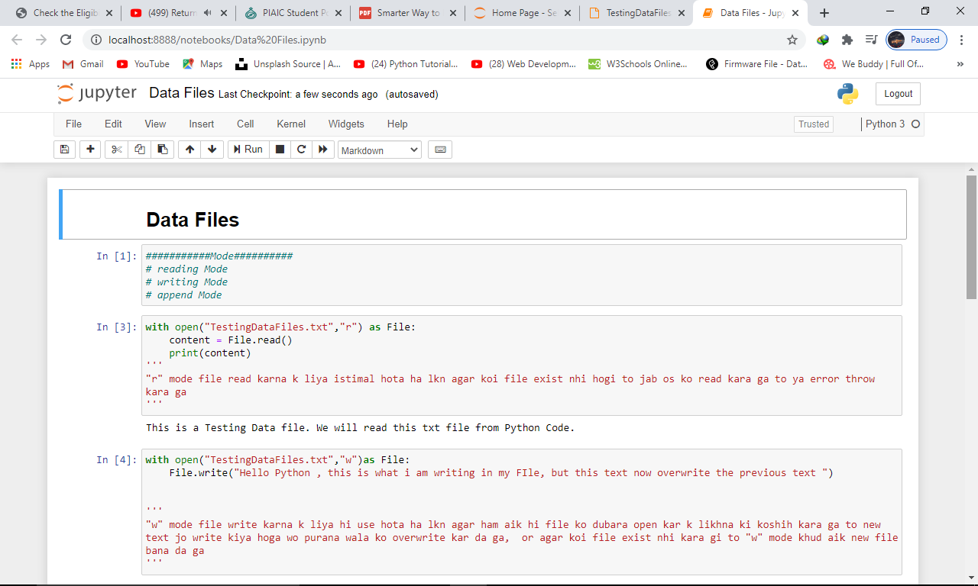

Reading writing in an external file from python Code:
We can write in a text file by using a python function:
With open(“file_name.txt”.”mode”)
There are three modes:
Read, Write, & append

Writing to a text File
With open (“myFile.txt”,”w”) as file:
File.write(“This is my file”)

Note: if file does not exist, “w” mode will create and write in it.

Reading from a text File:
With open (“myFile.txt”,”r”) as file:
Content_of_file = file.read()
Print(content)
Note: if file does not exist, “r” mode will throw file not found error.

Writing a file in append mode:
With open (“myFile.txt”,”a”)as file:
File.write(“This text is written in append mode”)

Note: in “w” mode if we write in same file all previous work will be overwrite. But append mode allows to write further.

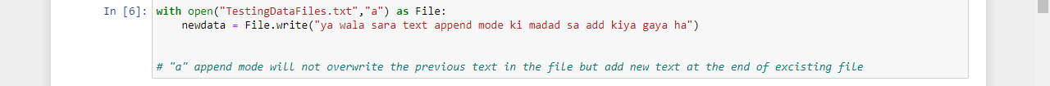
Data Files in r+, w+ mode:
r+ mode allows read and write both in files 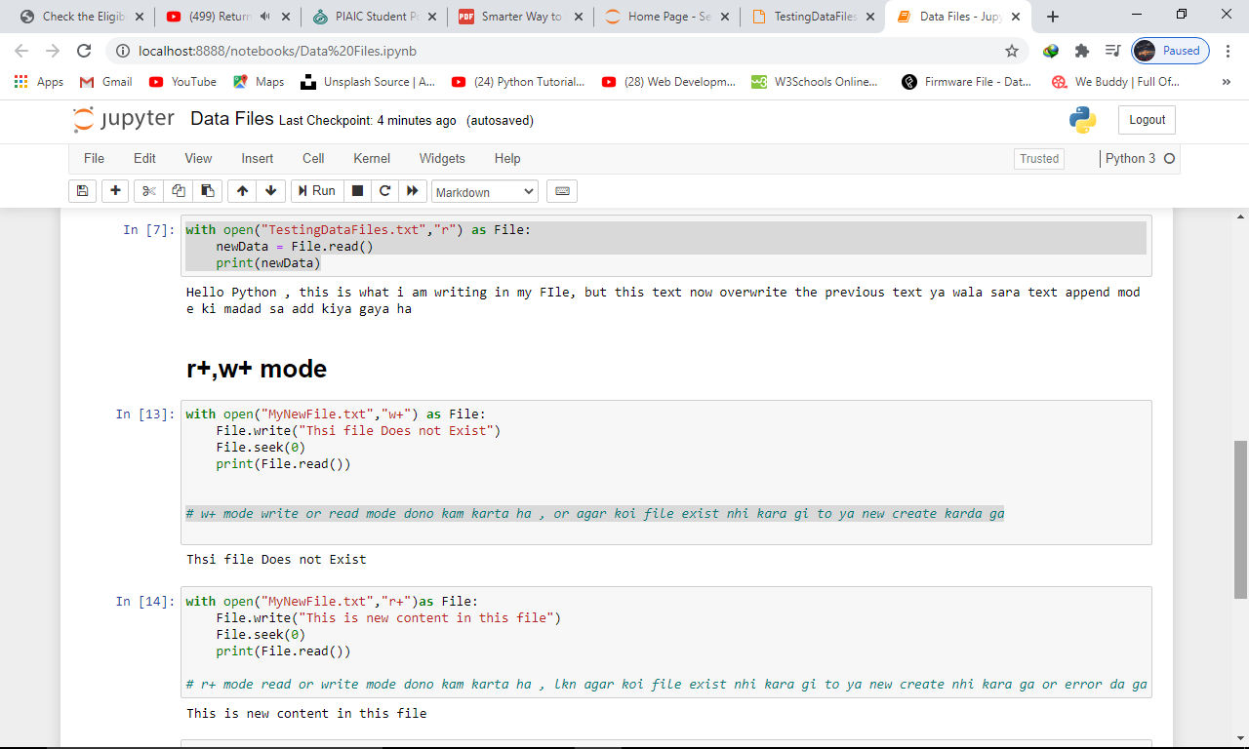

w+ mode allows read write both in files

